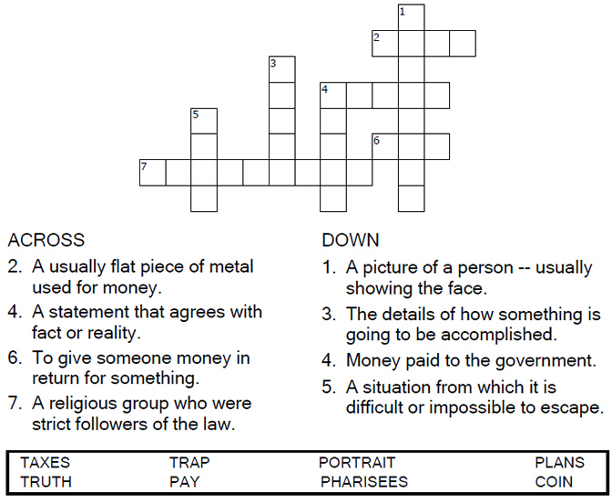


Copyright © Sermons4Kids, Inc.
May be reproduced for Ministry Use
Children’s Worship Bulletin

Paying Taxes to Caesar

Matthew 22:15-22

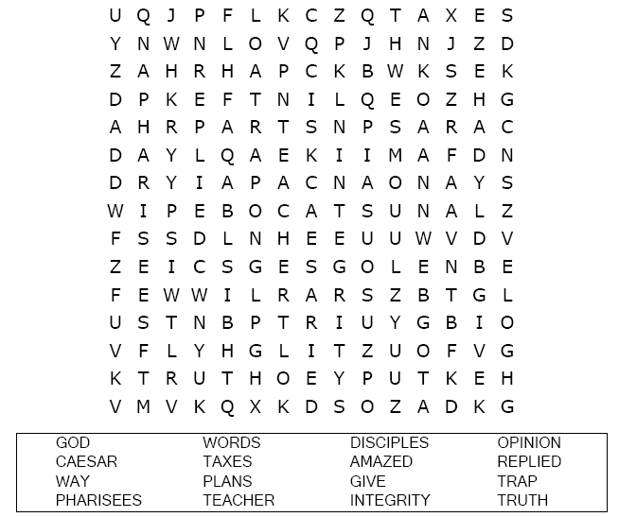
Faith United Methodist Church

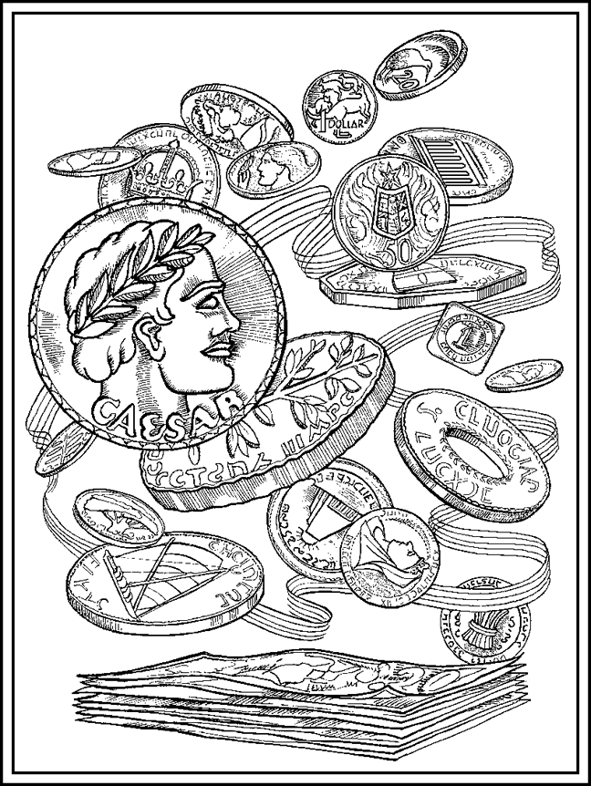
“Give to Caesar what is Caesar’s, and to God what is God’s”
Matthew 22:21.
Copyright © ABDA ACTS Art & Publishing
Used by permission.

Choose the word that best matches the definition.

